**14th Annual Conference of**



**French Riviera and Monaco: 20th – 23rd October 2016**

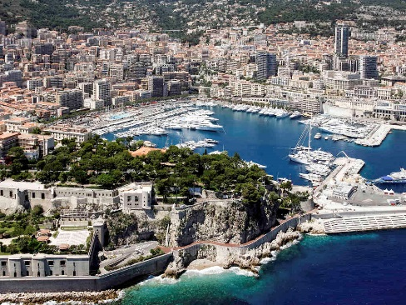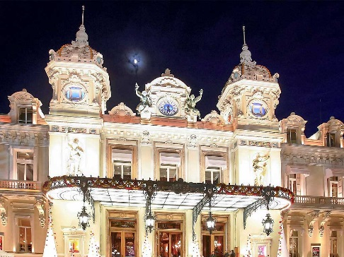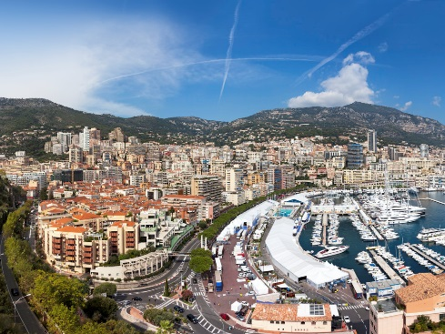

**PROGRAM**

**Thursday 20th October – Arrivals & Welcome**

Time: 8:00 pm – 10:00 pm

Attire: Smart casual

Cost: € 30 per person

Welcome reception and cocktails at STAR DECK with an open bar of wine, beer and soft drinks as well as snacks such as popcorn, focaccia, pretzels, nuts, crackers mix, hummus, crudités, mini bagels with smoked salmon, mini-burgers and chicken fingers.

The STAR DECK bar overlooks Monaco harbor and is easily accessible by foot from your hotel.

**STARS’N’BARS**

6 Quai Antoine 1

98000 Monaco

T +377 97 97 95 95

<http://www.starsnbars.com/en/star-deck/>

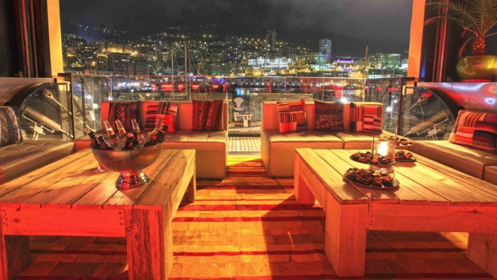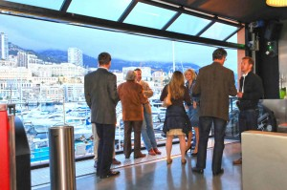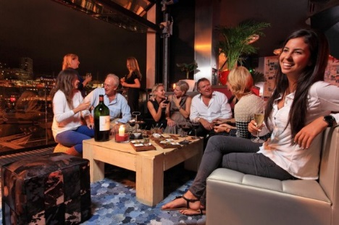

**14th Annual Conference of**



**French Riviera and Monaco: 20th – 23rd October 2016**

**Friday 21st October – AAC Conference - Novotel Monte Carlo**

Time: 9:30 am – 5:00 pm

Attire: Casual

Cost € 36 per person

The annual meeting will take place at the Novotel, Monte Carlo where you will be staying.

The meeting room will be equipped with: screen, beamer, flipchart, lectern, laptop and mineral water.

A sandwich lunch (Le Plateau) will be served in the meeting room, followed by an afternoon coffee/tea break.

**NOVOTEL MONTE CARLO HOTEL**

16 Bld Princesse Charlotte

98000  MONACO

Tel. (+377) 99998300‬‬‬‬‬‬

http://www.accorhotels.com/gb/hotel-5275-novotel-monte-carlo/index.shtml

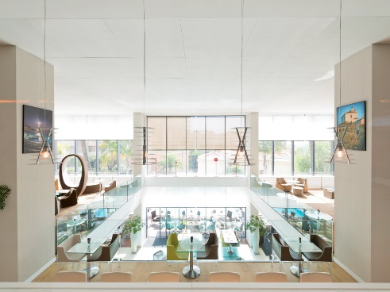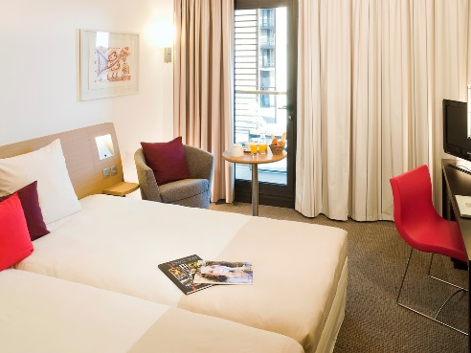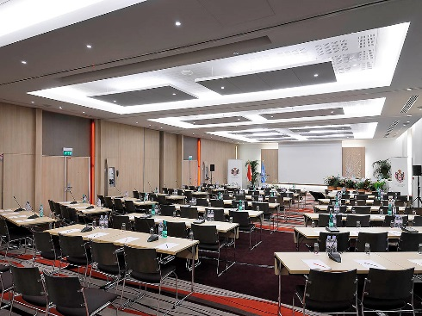

**Friday 21st October – AAC Reception & Dinner**

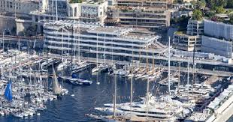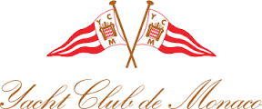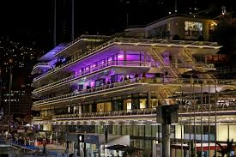

**Yacht Club de Monaco**

Time: 8:00 pm

Attire: Jacket & Tie

Cost: €90 per person (3 course dinner, including mineral water, wine and coffee)

Location: Yacht Club de Monaco. Dinner is limited to 40 guests.

http://www.yacht-club-monaco.mc/en/home-en/

**14th Annual Conference of**



**French Riviera and Monaco: 20th – 23rd October 2016**

**Saturday 22nd October – Guided tour and lunch at the home of the Baroness.**

**Villa & Jardins Ephrussi de Rothschild.**

Time: 11:00 am – 4:00 pm

Attire: Casual

Cost: € 47.50 per person (based on 50 participants)

A walk in the footsteps of the Baroness Ephrussi de Rothschild will take us from trivialities to works of art and magnificent gardens. When the Baroness held a soirée at the turn of the 20th century, all members of high society on the Riviera would eagerly travel to her luxury villa on the Cap-Ferrat peninsula. The Baroness was a great lover of flowers and would often bring back plants from her travels which were exotic or which had unusual essences.

We will enjoy a 3 course lunch, including mineral water, wine and coffee in The Tea Room that Béatrice Ephrussi de Rothschild used as a dining room. The Tea Room´s terrace overlooks the Bay of

Villefranche-sur-Mer.

<http://www.villa-ephrussi.com/en/home>

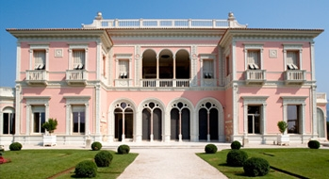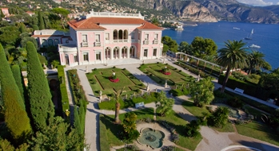

**Sunday 23rd October - Palace Tour and Lunch in the Old Town of Monaco**

Join us for a private tour of the Monaco Palace, view the changing of the Guard and then enjoy a three-course lunch with wine, water and coffee at l'Aurore Restaurant nearby.

Places are limited to 25 people.

Time: 10:15 am Meet in the front of the Palace

Attire: Casual

Cost: €35 per person

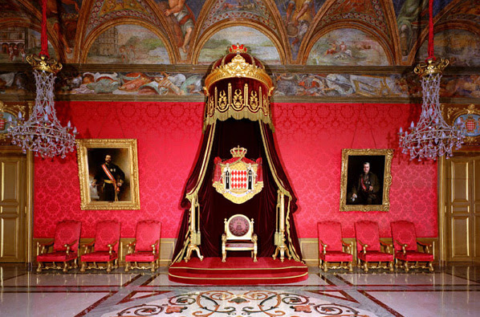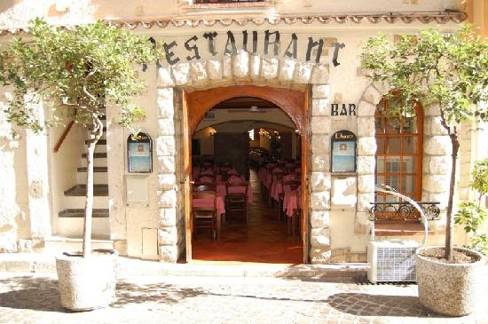

**14th Annual Conference of**



**French Riviera and Monaco: 20th – 23rd October 2016**

**PRACTICAL INFORMATION**

**HOTEL**

**NOVOTEL MONTE CARLO HOTEL**

**16 Bld Princesse Charlotte**

**98000  MONACO**

**Tel. (+377) 99998300‬**‬‬‬‬‬‬

[**http://www.accorhotels.com/gb/hotel-5275-novotel-monte-carlo/index.shtml**](http://www.accorhotels.com/gb/hotel-5275-novotel-monte-carlo/index.shtml)

€ 160/night/single room incl. breakfast, taxes & service (registration form attached)

€ 175/night/double room incl. breakfast, taxes & service

Superior room: A modern spacious room with king size bed, en suite bath/shower, sofa bed, large ergonomic work area, 26" LCD TV with pay movies and internet access, broadband connection, hair dryer, mini bar, tea/coffee.

Contact:

Mr. Jérome Arnoux

Sales Executive

Novotel Monte-Carlo

Tel. +377 99 99 83 05

[Jerome.arnoux@accor.com](mailto:Jerome.arnoux@accor.com)

**RESERVATIONS**

For all 5 events on [www.americanclubriviera.com](http://www.americanclubriviera.com) Home Page

**TRANSPORTATION**

**By rail (SNCF):** From Nice Saint-Augustin (from airport to station is 10 minutes walk) to Monaco Monte Carlo train station, Beausoleil exit (links to all the major European cities served by the TGV). From Monte Carlo station to hotel is 5 minutes walk.

**http://www.sncf.com**

**By bus:** Nice Airport – Monaco Express. Route 110. Runs every half hour from Nice Airport to Monaco.

[**http://uk.niceairportxpress.com**](http://uk.niceairportxpress.com)

**By air:** Nice Côte d'Azur International Airport is 15.5 miles (25 km) from the hotel. Transfers take 40 minutes by taxi or 7 minutes by helicopter.

**By car:** the Principality is linked to France and to all major European cities by the highway network accessible via the A8. The hotel has secure parking spaces (height limit: 6.8 ft/2.1 m).

**Contact for further information**

Burton Gintell: t) 04 93 38 22 24 m) 06 20 40 11 28 e) President@Americanclubriviera.com

